Variables & Arithmetic Operations

Problem Statement
Declare variables for product quantity and price. Calculate the sum and product.
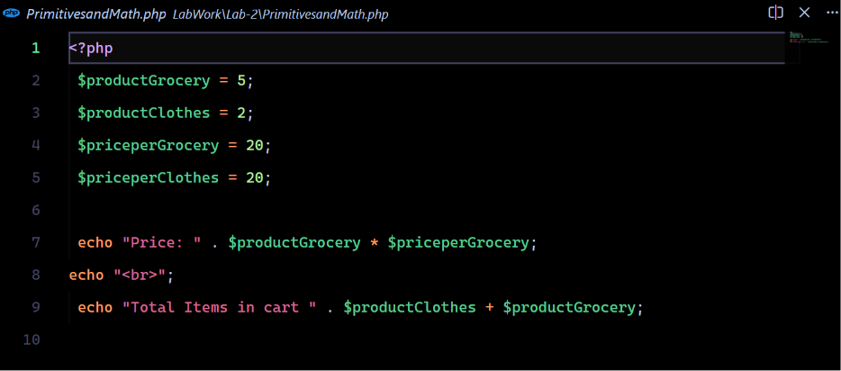
Source Code:

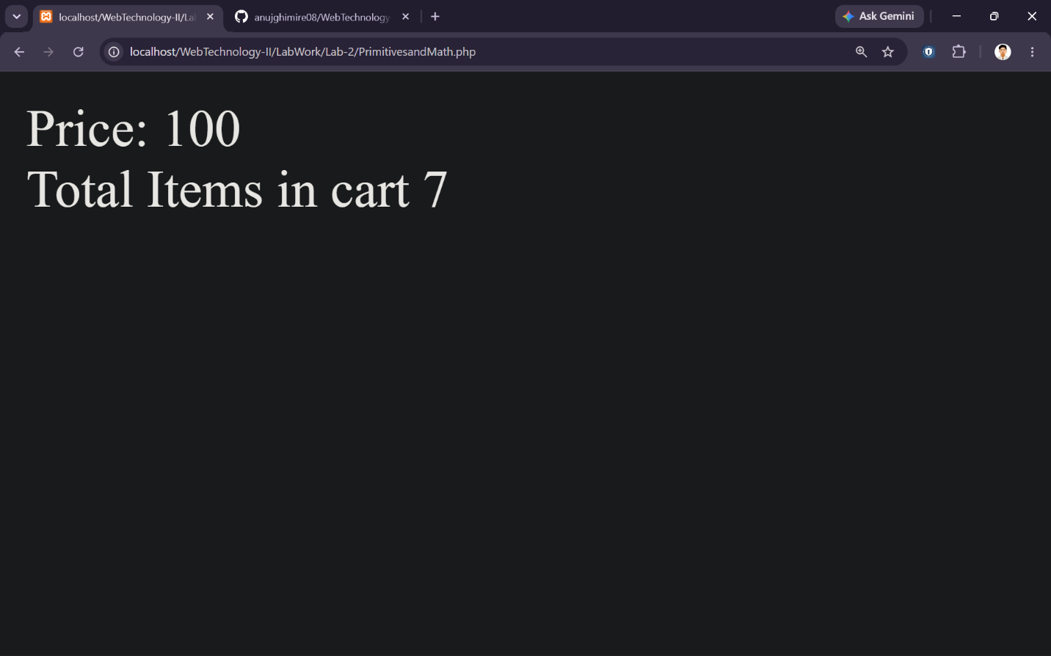
Output:
Constants & Variables

Problem Statement
Create a constant and compare it with a variable.
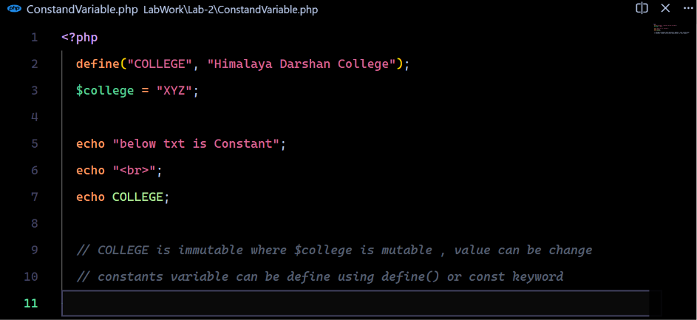
Source Code:

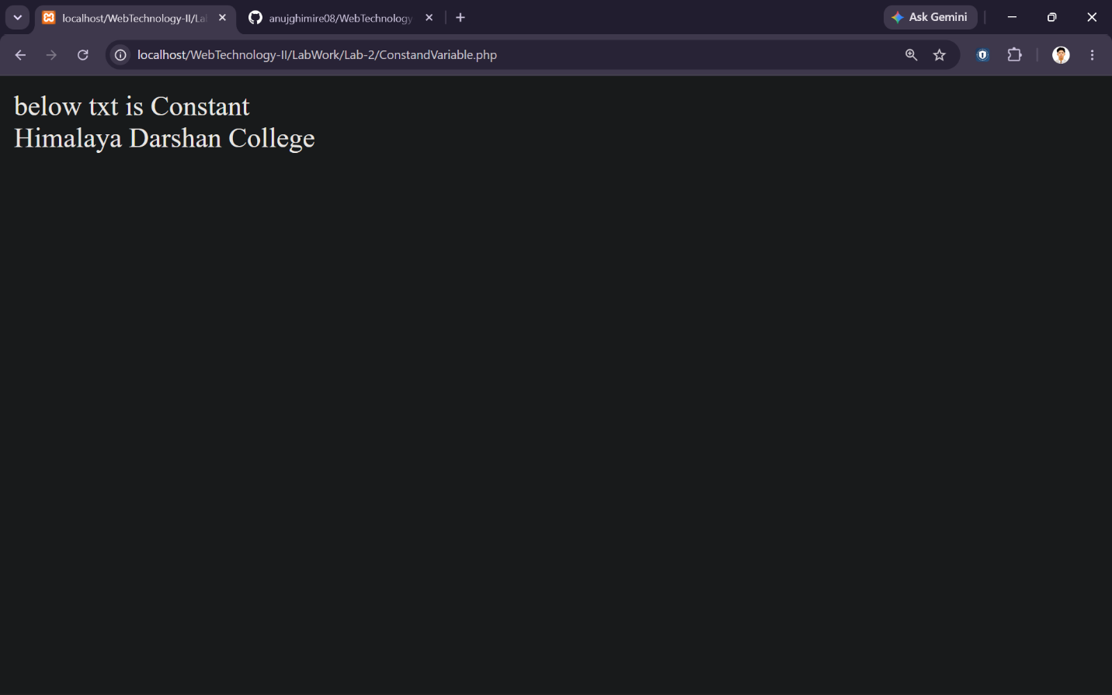
Output:
Operators

Problem Statement
Demonstrate Arithmetic, Assignment, Logical and Increment operators.
Source Code:
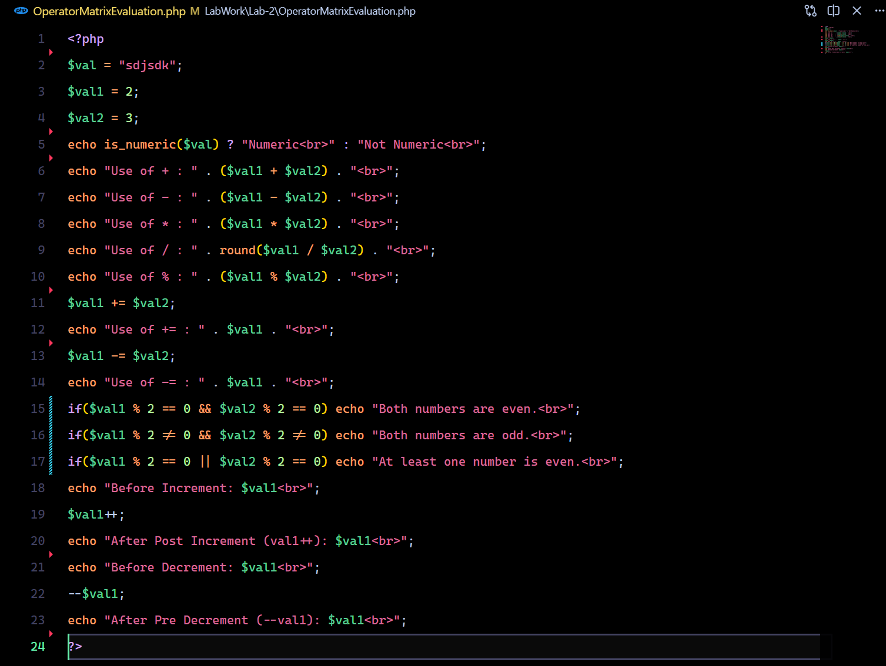
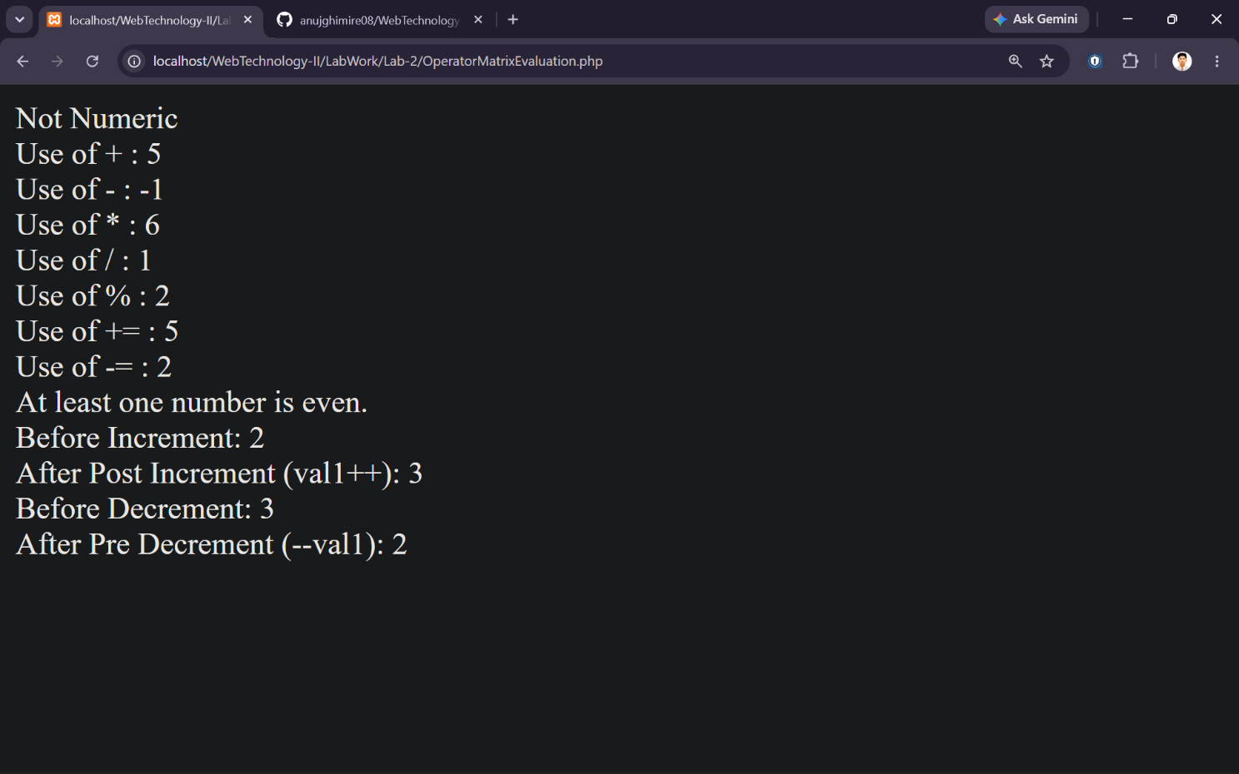
Output:
If-Else & For Loop

Problem Statement
Check whether a student passes or fails. Print numbers from 1 to 5.
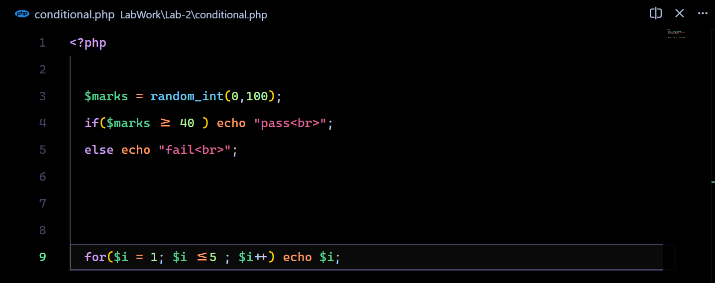
Source Code:

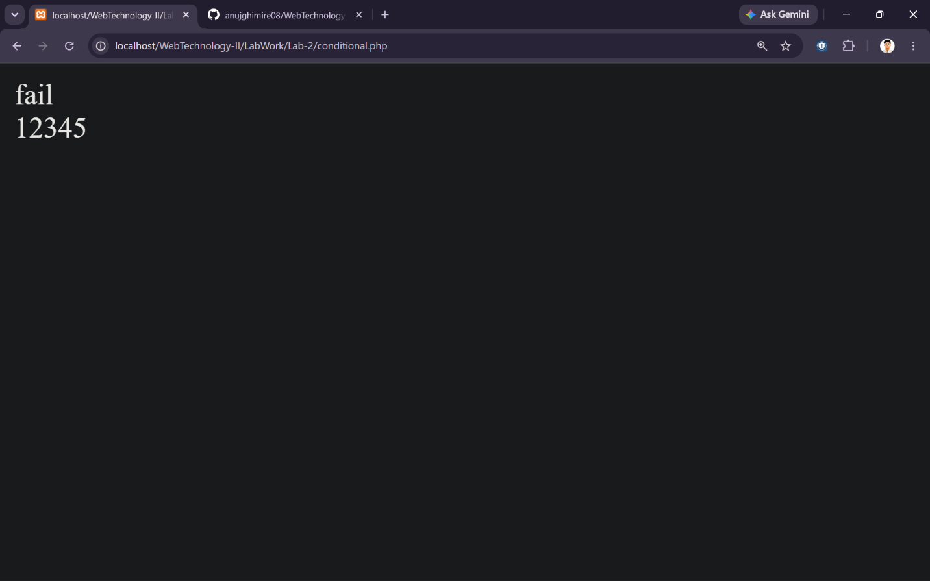
Output:

While & Do-While Loop

Problem Statement
Demonstrate while, do-while.
Source Code:
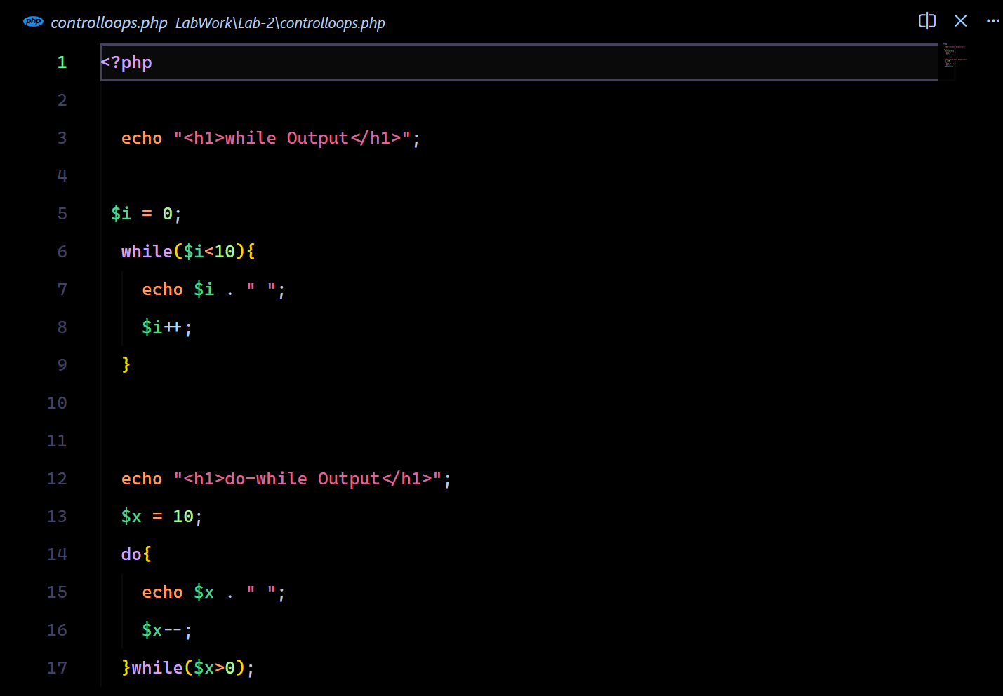

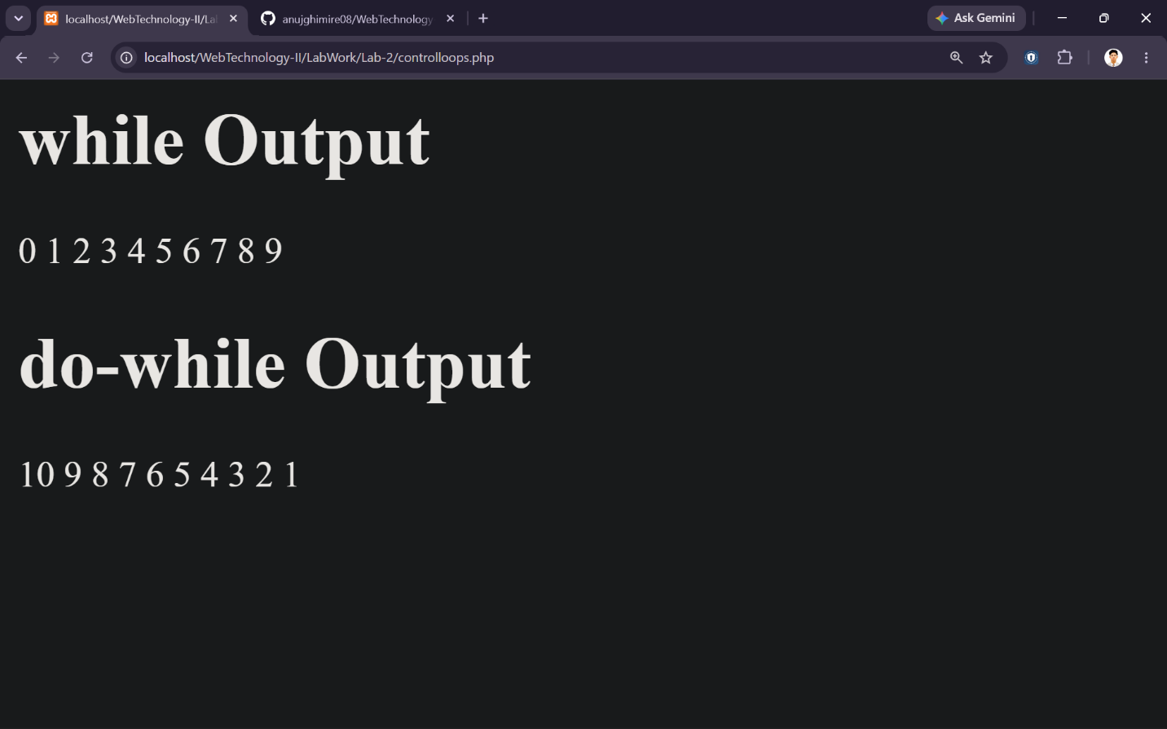
Output:

